School of Art & Art History
2012 Student - Studio Art Safety Procedures & Release Forms

Student version

You will receive a URL from ICON as follows or just simply type it in

https://icon.uiowa.edu/support/int/saahs/

1-This link will bring you to this page and log in with your HawkID and Password.

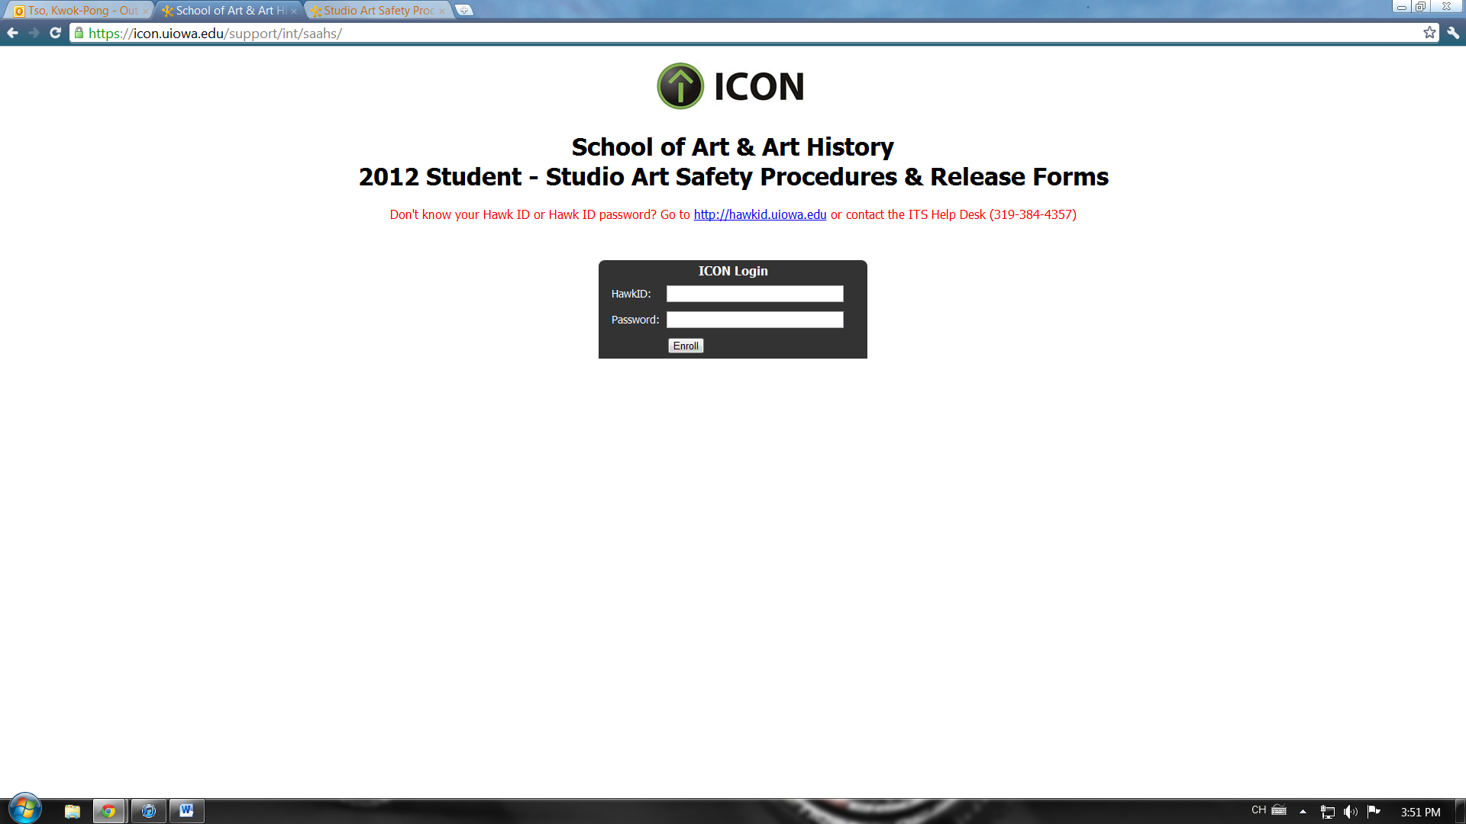

2-After logging in you will see this page. Click on Couse Home and select your discipline (Ceramics, 3D Design, sculpture, Metals, Graphic design, Intermedia, Printmaking, Painting Drawing, Woodshop).

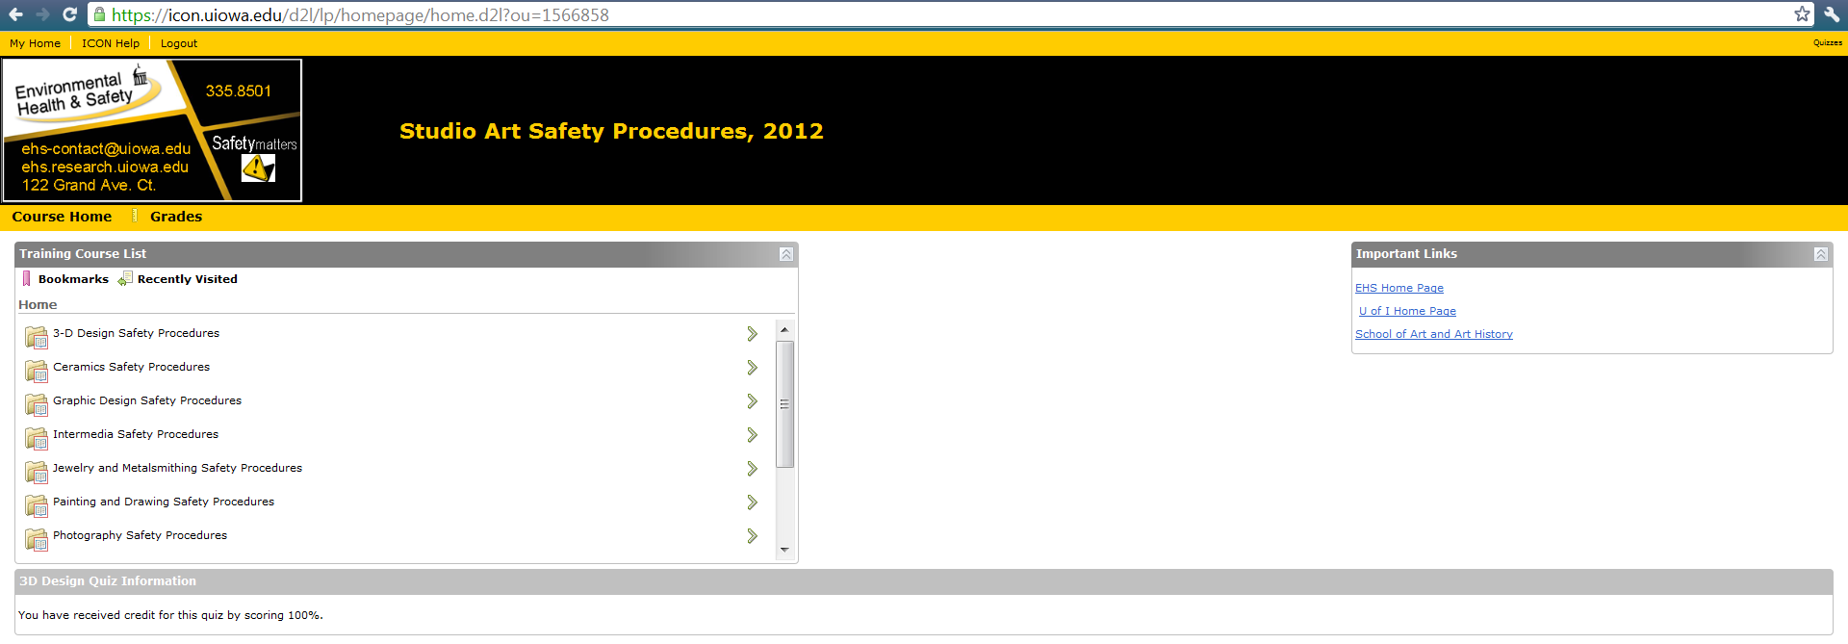

3-After you selected your area you will see Training Module and Quiz. You will have to read and save the Training Module for yourself and then click on Start Quiz to start your Quiz.

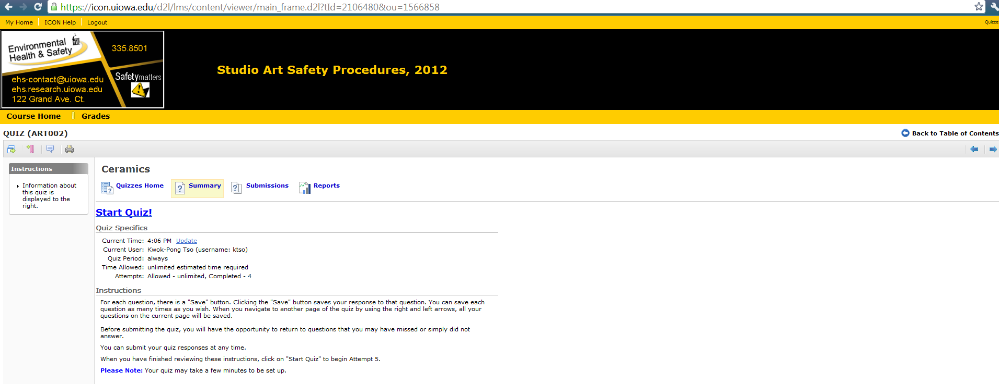

When you finish the quiz …it will ask you to save the answer and submit the answer…after you submitted the Quiz…. it will bring you to this page

Save the page by doing the following step

For window user: click PrintScreen key on your keyboard > open word > Ctrl+V>save>submit the word file to ICON dropbox

For Mac user: Press the Apple key ⌘ + Shift + 3 all at the same time > You will find a capture of the screen on your desktop>submit the word file to ICON dropbox

How to use ICON DropBox

Log in to icon with your hawkID and Password

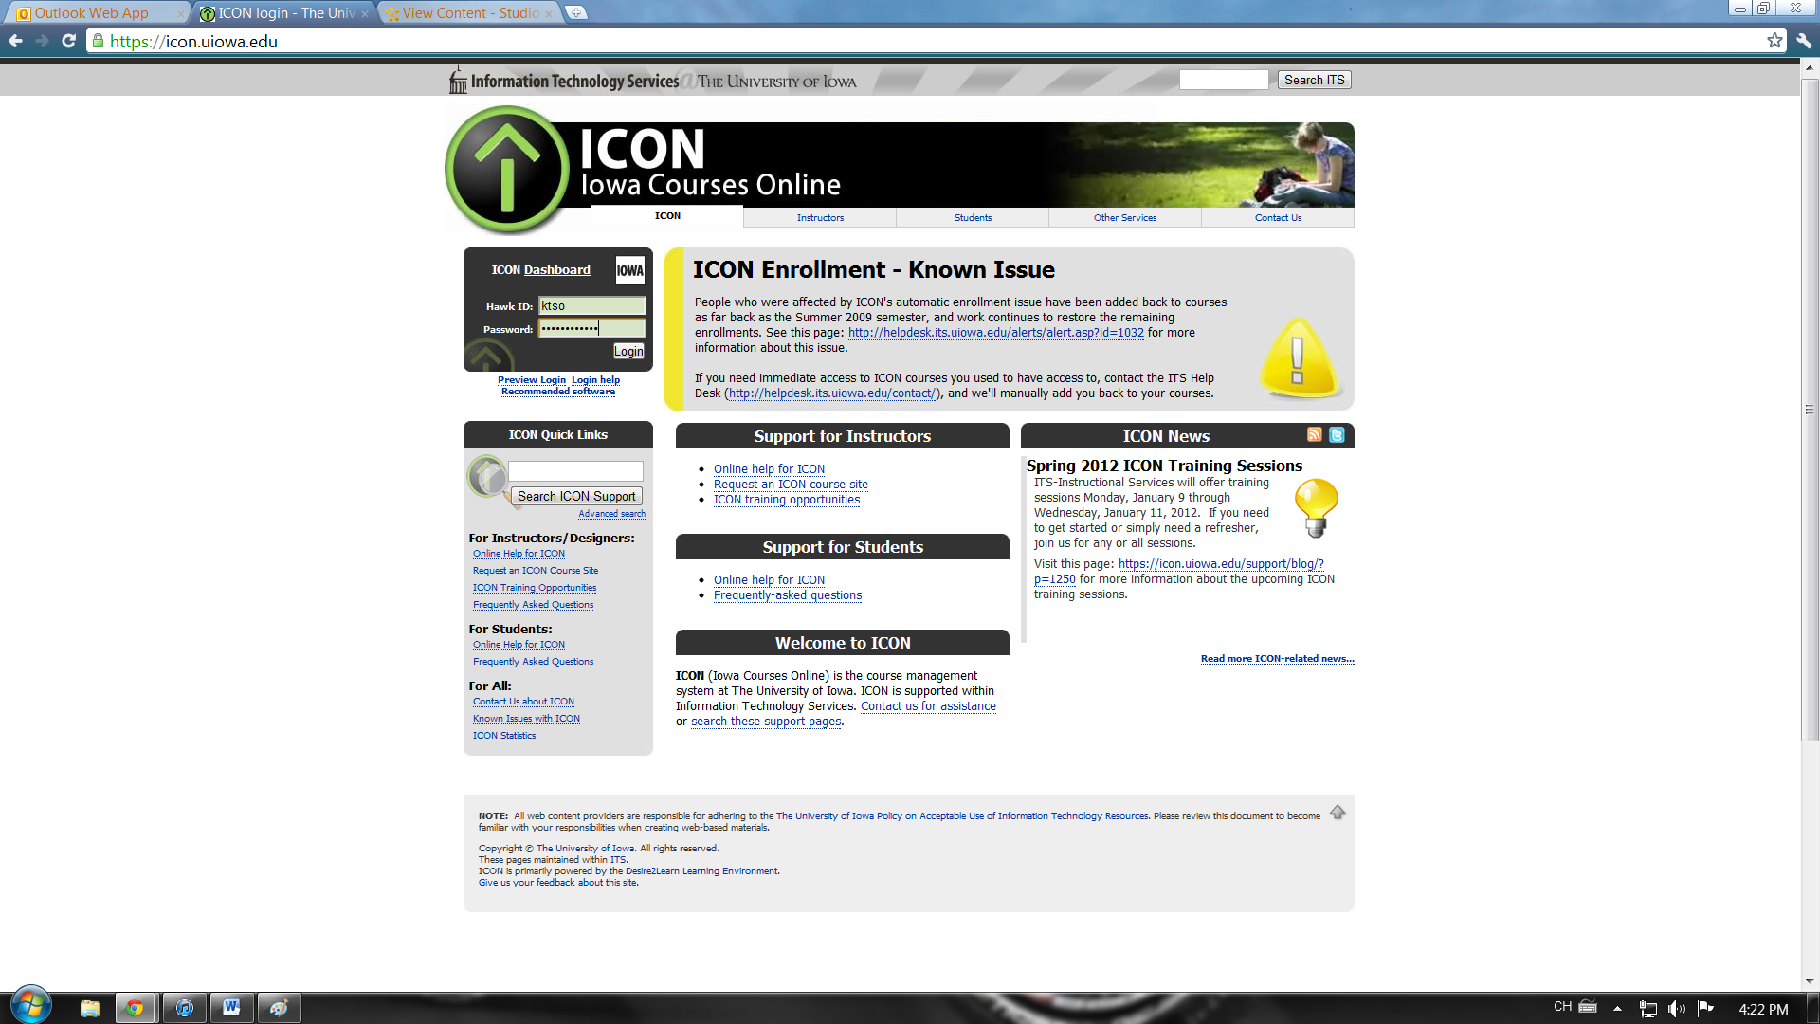

Once log in select the class ….you are going to submit your quiz result to

The dropbox should be open and named “Safety-your Instructor’s last name-class number”

Click on the folder and attach the file you have created after the safety Quiz by clicking “add a file” and hit submit.

You are now complete.

